**Day 1**

Down syndrome (DS) is a genetic disorder caused by the presence of all or part of a third copy of chromosome 21. It is typically associated with physical growth delays, characteristic facial features, and mild to moderate intellectual disability. It’s not a disease, people with DS don’t “suffer” from it.

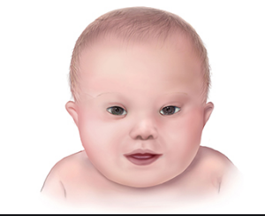

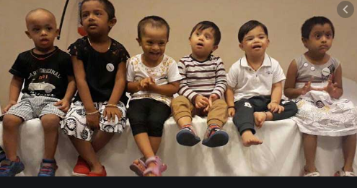

**Day 2**

India being one of the highest populated nations, there is greater incidence of Down Syndrome and it occurs in approximately 1 out of 830 live births. Down syndrome the most common chromosomal condition.

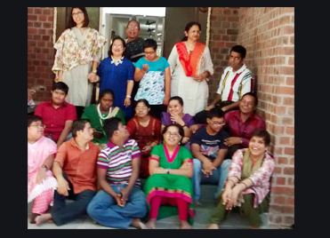



**Day 3**

The word 'Down' in Down syndrome is not used as an adjective. It rather is a proper noun because the Syndrome is named after Dr. John Langdon Down who for the first time described it in 1862.

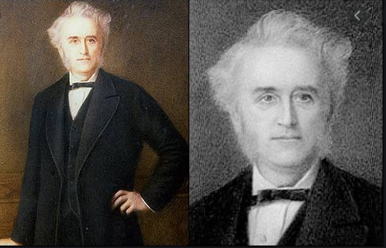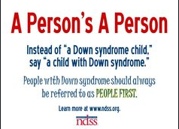

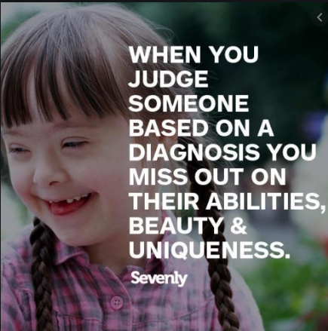

**Day 4**

Symptoms of Down syndrome aren’t the same for each person.  
The genetic disorder causes many distinct characteristics, like a small stature, upwardly slanting eyes, a flattened bridge of the nose, a short neck, a single deep crease across the palm of their hand and low muscle tone. However, each person will have different degrees of the characteristics, and some of the features may not appear at all.

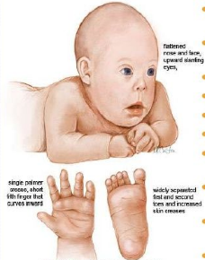

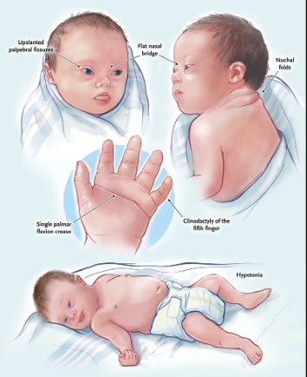

**Day 5**

Scientists have identified three different types of Down syndrome  
**Trisomy 21**: This occurs when there’s an error in the cell division called ‘nondisjunction’ which results in three chromosomes in an embryo instead of two.  
**Mosaicism**: This occurs when there’s a mix of two types of cells, some containing 46 chromosomes and some with 47. The ones with 47 contain the extra 21 chromosome.  
**Translocation**: This type is relatively less common. In this scenario, the number of chromosomes remains 46 but an additional or partial copy of chromosome attaches to another chromosome.

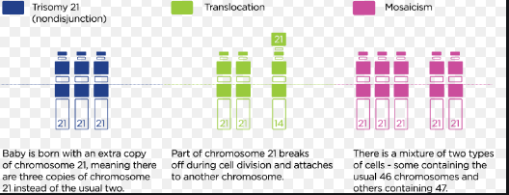

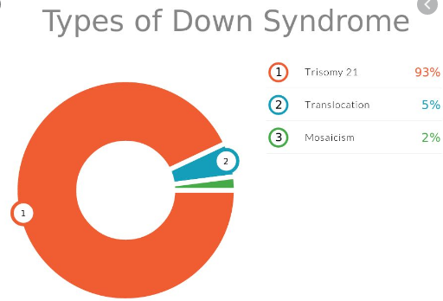

**Day 6**

Most children with Down syndrome are born to women younger than 35 years old simply because younger women have more children. However, the likelihood of having a child with Down syndrome increases with the age of the mother, especially after age 35. Several tests can be done on pregnant women to determine their risk of having a Down syndrome baby. A positive screening test can be followed up by an amniocentesis.

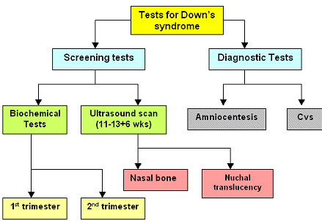

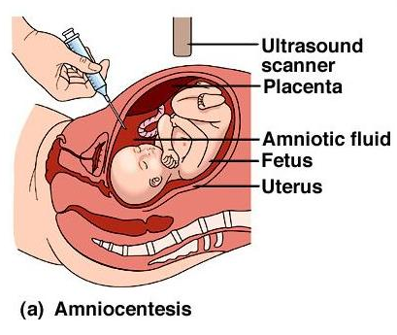

**Day 7**

In 1983, the average life expectancy of a person with Down syndrome was a mere 25-years-old. Today, it’s 60.



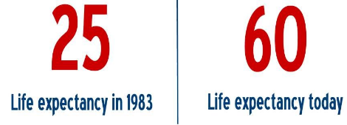

**Day 8**

Most people with Down syndrome have a mild to moderate cognitive disability, or intellectual disability. This is not indicative of the many strengths and talents that each individual possesses. Children with Down syndrome go through the same stages of development as typical children but it takes a little longer to achieve those milestones. Be considerate of the extra time it might take a person who has a disability to get things done or said.



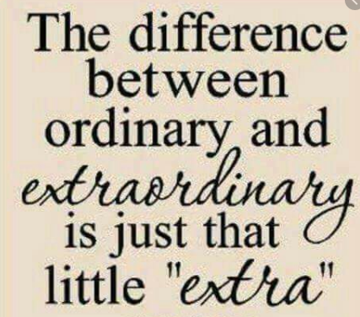

**Day 9**

People with Down syndrome have an increased risk for certain medical conditions such as congenital heart defects, respiratory and hearing problems, Alzheimer’s disease, childhood leukemia and thyroid conditions. Many of these conditions are now treatable, so most people with Down syndrome lead healthy lives

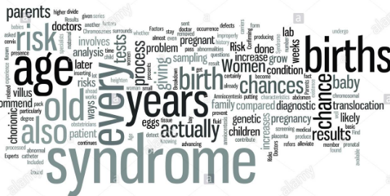

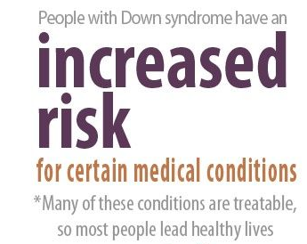

**Day 10**

One of the most significant challenges for people with Down syndrome is low muscle tone. Low muscle tone affects speech, gross motor skills, and fine motor skills. Speech, physical, and occupational therapy help.

